**SARA SALEEM**

**CA/AP1/7683**

**Domain: Cyber security**

**Task 1**

**Basic network sniffer**

**Step 1**

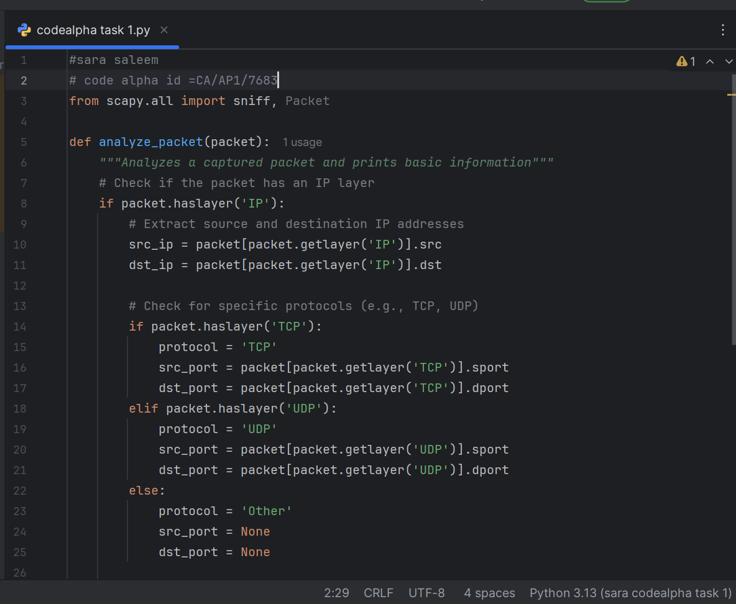

Step 2